Content

CHAPTER 1: Abstract
CHAPTER 2: Introduction
CHAPTER 3: Brief Introduction of the Drawing
CHAPTER 4: Detailed Description of the Embodiments
CHAPTER 5: Technical Specification
CHAPTER6:Conclusion

CHAPTER 1
ABSTRACT
Bicycles have traditionally operated as a single-wheel drive vehicle. As is evidenced by their popularity, single wheel-drive bicycles are suitable in most cases. Because they only employ single-wheel drive, however, the use of bicycles are, for the most part, somewhat limited to prepared surfaces such as paved streets, sidewalks, and groomed paths. Although just about everyone who has ever ridden a bicycle has ridden on gravel or unprepared surfaces, all riders know that it is more difficult to ride on these types of surfaces due to the fact that drive is being generated by only the rear wheel. In any event, single-wheel-drive bicycles are the norm because of difficulties involved in transferring to the front wheel the drive generated by the rider. The difficulty in generating drive via the front wheel of a bicycle results from the need to allow the fork (on which the front wheel is mounted) freedom to turn substantially in either direction from the centre position in order to permit the cyclist to steer the bicycle. Because the fork must be free to turn, it is not possible to directly connect the pedals to the front wheel. While two-wheel-drive bicycles have been proposed, there remains need for an easily-operable and readily steer able two-wheel-drive bicycle, so that riders will have greater opportunity for enjoyable cycling on off-road trails and other unprepared surfaces. Therefore, a two-wheel-drive bicycle overcoming various problems and shortcomings of the prior art would be an important improvement in the art.

CHAPTER 2
INTRODUCTION

Two-wheel drive (2WD) describes vehicles with a drive train that allows two wheels to receive power simultaneously.
A two-wheel drive cycle comprises a frame, a front fork assembly mounted on the frame through a pivotal connection to steer the cycle, a front wheel rotating on the fork assembly about a first axis, and a rear wheel rotating on the frame about a second axis. A front sprocket is mounted on the front wheel and centered on the first axis to drive the front wheel, while a rear sprocket is mounted on the rear wheel, is centered on the second axis and driven through the pedals or motor. A chain is meshed with both the front and rear sprockets and guided between these front and rear sprockets through a plurality of gears and pulleys, including a set of gear and pulley engaging the chain and rotatively mounted on the frame close to the pivotal connection. A spring mechanism lengthens and shortens the chain loop as the front fork assembly is turned. In operation, the front wheel is driven through the pedals or motor, the rear sprocket, the chain meshed with both the front and rear sprockets, and the front sprocket.
For two-wheeled vehicles such as bicycles, the term is used to describe vehicles which can power the front as well as the back wheel. This scheme greatly improves off-road performance, but is quite complicated and requires more power to operate, thus most 2WD machines are either "exotic" bikes for enthusiasts or created with special uses in mind.

CHAPTER 3
BRIEF DESCRIPTION OF THE DRAWINGS

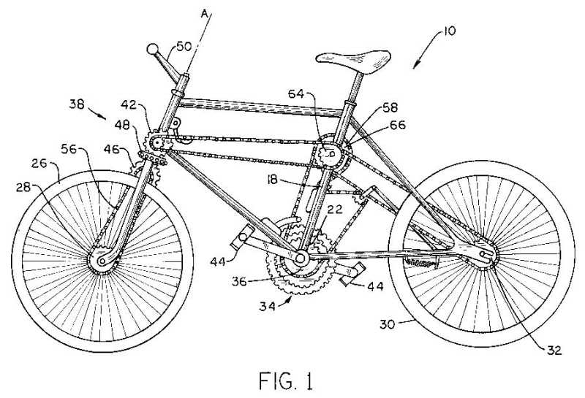
Fig. 1 is a side view showing the left side of a two wheel-drive bicycle.

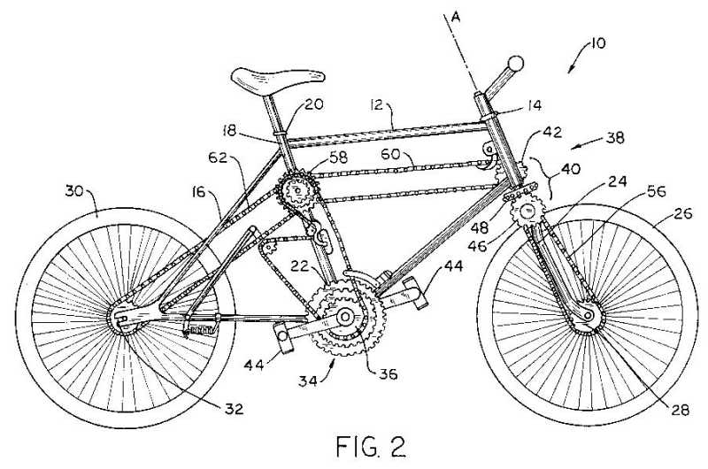
Fig. 2 is a side view showing the right side of the two-wheel-drive bicycle of Fig. 1
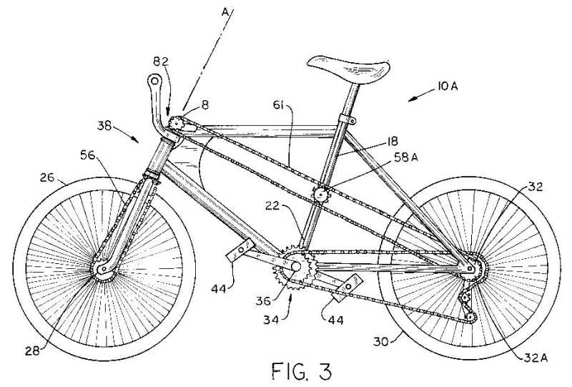
Fig. 3 is a side view showing the left side of an alternative embodiment of the two-wheel-drive bicycle.

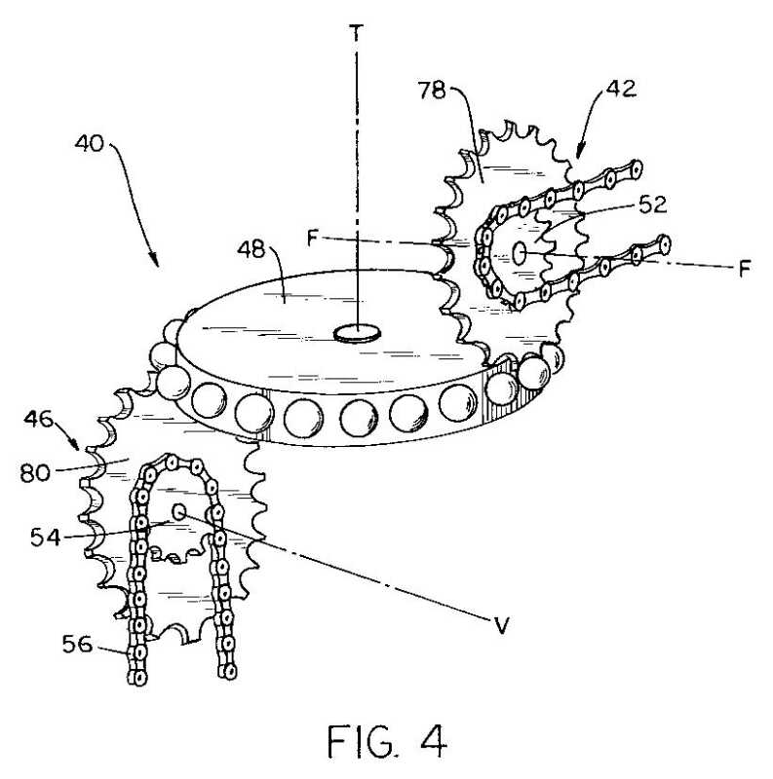
Fig. 4 is a schematic perspective view of the front gear arrangement for the two-wheel-drive bicycle of Fig. 1 and 2.

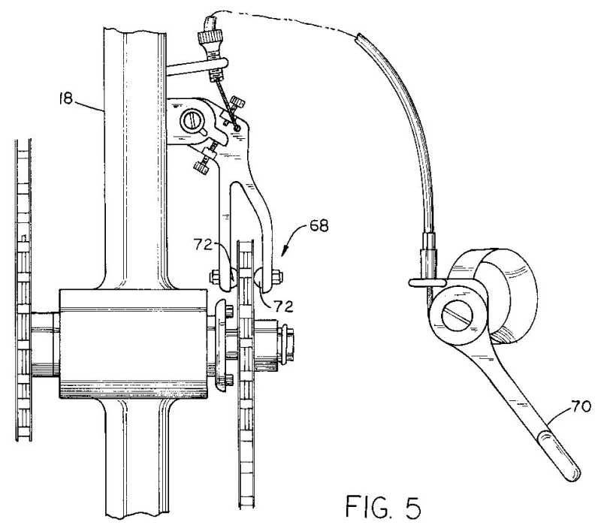
FIG. 5 is a front view of a clutch engaged to the centre portion of a frame of such two-wheel-drive bicycle.

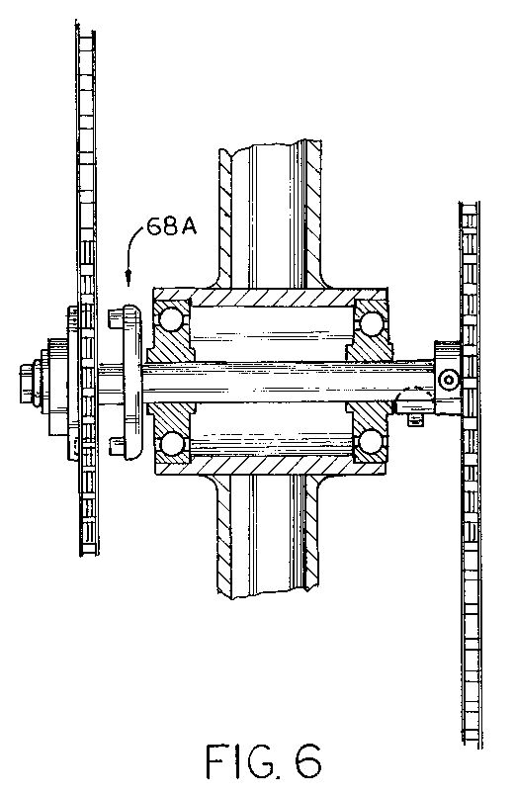
Fig. 6 is a sectional view of the clutch assembly.

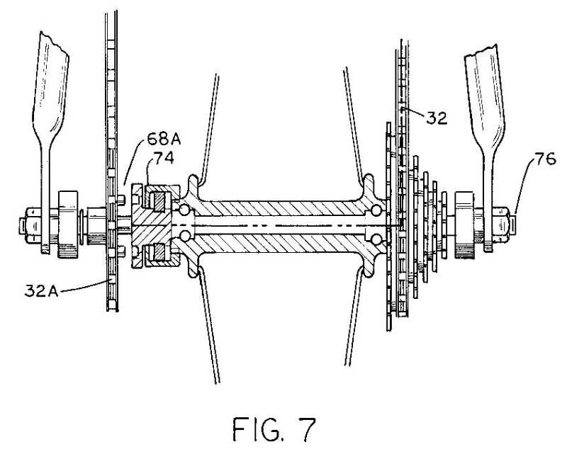
Fig. 7 is a sectional view showing the clutch assembly mounted on the rear hub of a two-wheel-drive bicycle.
FIG. 8 is a front view of the fork assembly showing the front gear arrangement of the two-Wheel-drive bicycle of FIGS. 1 and 2.

FIG. 9 is a right side elevation of the front portion of the
frame of the two-Wheel-drive bicycle of FIG. 3, showing one
preferred embodiment of the front gear arrangement.

FIG. 10 is a side sectional of the apparatus of FIG. 9,
taken along section 10—10 as indicated in FIG. 9.

CHAPTER 4
DETAILED DESCRIPTION OF THE EMBODIMENTS

As shoWn in FIGS. 1—3, Which show two preferred embodiments 10 and 10A of the invention, the invention involves a two-Wheel-drive bicycle that includes: (1) a frame 12 having front and rear portions 14 and 16 and a center portion 18 With upper and lower ends 20 and 22; (2) a fork assembly 24 attached to front portion 14 and pivotable about a steering axis A; (3) a front Wheel 26 on the fork assembly, the front Wheel having a front sprocket 28; (4) a rear Wheel 30 on rear portion 16, rear Wheel 30 having a main rear sprocket 32; and (5) a drive mechanism 34 that includes a main-drive sprocket 36 at loWer end 22 of center portion 18.

The improvement involves a chain-driven front-drive mechanism 38, shown in various forms in the illustrated embodiments of this invention, and related driving appara tus. For example, in the embodiment of FIGS. 1 and 2, front-drive mechanism 38 has a gear arrangement 40 attached to fork assembly 24, Whereby gear arrangement 40 transfers rotational poWer from drive mechanism 34 along steering axis A to front sprocket 28. TWo-Wheel-drive bicycles 10 and 10A alloW the rider to traverse unimproved terrain as greater traction is generated using tWo drive Wheels than With conventional one-Wheel drive bicycles. In one embodiment, as shoWn in FIGS. 1, 2, 4 and 8, in order to generate greater traction, gear arrange ment 40 of tWo-Wheel-drive bicycle 10 includes a fixed-axis intermediate rotatable transfer device 42 that is attached to front portion 14 of frame 12 and mechanically engaged to drive mechanism 34 Which also includes the pedals 44 and the related components necessary to connect pedals 44 to main-drive sprocket 36. A variable-axis intermediate transfer device 46 capable of rotation is attached to fork assembly 24 and mechanically engaged to front sprocket 28, and a
drive-transfer Wheel 48 capable of rotation is attached to fork assembly 24 and engaged betWeen fixed-axis interme diate and variable-axis intermediate transfer devices 42 and 46, in such a manner that drive-transfer Wheel 48 mechanically links front sprocket 28 With main-drive sprocket 36 While alloWing bicycle steering. Further details of this steerable front gearing arrangement are set forth beloW.

When in operation, the rider generates the drive force by pedaling the tWo-Wheel-drive bicycle 10 in the conventional manner that is Well knoWn in the art. As the rider pedals, the
drive force is transferred via mechanical linkage to both rear and front Wheels 30 and 26. While various forms of mechanical linkage Would be encompassed Within the spirit f the invention, a sprocket-engaging chain similar to What is currently used on a bicycle is the preferred device for mechanically linking drive mechanism 34 to front and rear Wheels 26 and 30.

As shoWn best in FIGS. 4 and 8, fixed-axis intermediate gear arrangement 42 is one in Which the axis F around Which the gear rotates remainsfixed substantially perpendicular to
frame 12 of bicycle 10. Variable-axis intermediate gear arrangement 46 rotates around an axis V that varies in relation to frame 12 as front Wheel 26 is turned. That is variable-axis intermediate gear 46 rotates around an axis that is perpendicular to frame 12 When front 26 and rear 30 Wheels are aligned in tandem. When front Wheel 26 is turned, hoWever, axis V about Which variable-axis intermediate gear 46 rotates does not remain perpendicular to frame 12. This is because variable-axis intermediate gear 46 tracks around the circumference of drive-transfer Wheel 48. Such tracking is caused by the rotation of drive-transfer Wheel 48
that results from the engagement of drive-transfer Wheel 48 With rotating fixed-axis intermediate gear 42.

This gear arrangement permits the rider to freely turn the bicycle handle bars 50 thereby turning fork assembly 24. Such turning can be accomplished Without the need to adjust the tension in the mechanical linkage or accelerating the rotation of front Wheel 26 in relation to rear 30. This alloWsfor the smooth, safe operation of tWo-Wheel-drive bicycle 10.
In the embodiment shoWn in FIGS. 1, 2, 4 and 8, xed-axis intermediate rotatable transfer device 42 includes a rotary-drive input sprocket 52 and variable-axis intermediate rotatable transfer device 46 includes a rotary-drive output sprocket 54. In a particular version of such
embodiment, a front chain 56 engages variable-axis intermediate rotatable transfer device 46 to front sprocket 28.

Furthermore, as shoWn in FIGS. 1 and 2, a transverse idler sprocket arrangement 58 is connected to center portion 18 betWeen main-drive-sprocket 36 and top end 20 of center portion 18. extends tofixed-axis intermediate rotatable transfer device 42, and a second transverse-drive chain 62 engages transverse sprocket arrangement 58 and extends to rear sprocket 32. More speci?cally, transverse sprocket arrangement 58 includes afirst central-drive sprocket 64 attached to center portion 18 and a second central-drive sprocket 66 attached to center portion 18 and coaxially connected to first central-drive sprocket 64. The transverse drive chain arrangement includes a first chain 60 extending from fixed-axis intermediate rotatable transfer device 42 to first central-drive sprocket 64 and a second chain 62 extending from second central-drive sprocket 66 to rear sprocket 32. FIG. 3 shoWs an alternative arrangement in Which the driving force for front Wheel 26 is transferred there via chain 61 from a secondary rear sprocket 32A Which is a fixed to rear sprocket 32. In this example, a simpler idler sprocket arrangement 58A is used—a single sprocket Which merely
guides chain 61 and maintains appropriate tension therein.

In such embodiment, a rear-hub clutch is used. While the use of sprockets is preferred, such an embodiment does not preclude the use of some other type of Wheel or cylinder.
In other versions, a clutch 68, as illustrated in FIGS. 5—7, is used such that front-drive mechanism 38 can be disengaged from main-drive sprocket 36. Various types of clutches 68 are suitable for disengaging front-drive mechanism 38 from main-drive sprocket 36. HoWever, one version, shoWn in FIG. 5, involves the use of an engagement clutch 68 positioned on center portion 18 so as to be capable of engagingfirst central-drive sprocket 64. When in operation, the rider positions a lever 70 thereby causing pads 72 on clutch 68 to engagefirst central-drive sprocket 64. This engagement connects front sprocket 28 to main-drive sprocket 36. In another preferred version, shoWn in FIGS. 6 and 7, a clutch 68A is positioned so as to engage a ratchet assembly 74 located along the rear hub 76. In such embodiment, ratchet assembly 74 either transmits poWer to hub 76 or alloWs hub 76 to freeWheel in the same manner as a standard single-Wheel-drive bicycle.

Returning again to description of front gearing arrangement 40, as shoWn best in FIGS. 4 and 8, as already noted fixed-axis intermediate rotatable transfer device 42 rotates about axis F, and it is preferred that drive-transfer Wheel assembly 48 has a center axis T Which is perpendicular to and intersecting With axis F. Axis T is coaxial With the main axis about Which the fork of the bicycle turns during steering. Fixed-axis intermediate rotatable transfer device 42 is attached to a side of front portion 14 of frame 12 Which is opposite the position of variable-axis intermediate rotatable transfer device 46.

As shoWn in FIGS. 4 and 8, gear arrangement 40 includes afixed-axis intermediate sprocket assembly 42 rotatably attached to front portion 14 and having a first input sprocket 52 mechanically engaged to drive mechanism 34 and a first output sprocket 78. A variable-axis intermediate sprocket assembly 46 capable of rotating is attached to fork assembly 24 and includes a second input sprocket 80 and a second output sprocket 54 mechanically engaged to front sprocket 28, and a drive-transfer Wheel 48 circumscribing and rotatably attached to fork assembly 24 and mechanically engaged To first output sprocket 78 and second input sprocket 80, thereby providing front-Wheel drive While alloWing pivoting of fork assembly 24 for bicycle steering.

In a highly most preferred embodiment of the invention, illustrated by FIGS. 3, 9 and 10, the front gearing arrangement includes: (1) a fixed-axis intermediate sprocket assembly 82 rotatably attached to front portion 14 and having a first input sprocket 84 mechanically engaged to drive mechanism 34 and an output sprocket 85; (2) a firstfixed axis gear Wheel 86 attached to the front portion and mechanically engaged to fixed-axis intermediate sprocket 84; (3) a second gear Wheel 88 engaged With first fixed-axis gear Wheel 84 and circumscribing the steering axis A; (4) a drive shaft 89 (see FIG. 10) oriented along the steering axis Aand having first and second ends 90 and 92, Where first end 90 is connected to second gear Wheel 88 and second end 92 is connected to a third gear Wheel 94 oriented parallel to second gear Wheel 88; and (5) a fourth gear Wheel 96 engaged With third gear Wheel 94 and mechanically engaged to output sprocket 85, and from there to front sprocket 28 by means of chain 56 (see FIGS. 3 and 9). First, second, third and fourth gear Wheels 86, 88, 94 and 96 are beveled gears having spiral gear faces.

When in operation, a sprocket chain 61 (see FIG. 9) transfers poWer to first fixed-axis gear Wheel 86 via sprocket 84. This causes first fixed-axis gear Wheel 86 to rotate. Such rotation cause the rotation of second gear Wheel 88 Which results in rotation of drive shaft 89. The rotation of drive shaft 89 causes third gear Wheel 94 to rotate Which results in the rotation of fourth gear Wheel 96, and thus the rotation of output sprocket 85, Which in turn causes sprocket 28 and front Wheel 26 to turn. This arrangement, as by noW is apparent, does not in any Way interfere With steering of TWo-Wheel-drive bicycle 10A, because the upper pair of
beveled gears involves transfer of driving force from a fixed-axis gear to a variable-axis gear, Which generates drive power to front Wheel 26 in any turning orientation. While tWo-Wheel drive bicycle 10A illustrated in FIGS. 3, 9 and 10 is shoWn as receiving poWer to the front via chain 61, Which extends from the rear Wheel area,fixed intermediate sprocket assembly 82 can alternatively be driven by the chain 60 of the arrangement illustrated in FIGS. 1 and 2.
Indeed, Within the spirit of this invention, a number of alternative approaches are possible.
As used herein, the terms “gear arrangement” or “gearing arrangement” or the like are not, as should be apparent, in any sense limited to arrangements involving toothed gears. Instead, any common sorts of mechanical power transferring devices, obviously including Without limitation sprockets, chains and the like, can be used.

CHAPTER 5
TECHNICAL SPECIFICATION

Bicycle wheel

A bicycle wheel is a wheel, most commonly a wire wheel, designed for bicycle. A pair is often called a wheelset, especially in the context of ready built "off the shelf" performance-oriented wheels.
Bicycle wheels are typically designed to fit into the frame and fork via dropouts, and hold bicycle tires.
Sizes
Bicycle rims and tires came in many different types and sizes before efforts were made to standardize and improve wheel/tire compatibility. The International Organization for Standardization (ISO) define a modern, unambiguous system of sizing designations and measurement procedures for different types of tires and rims in international standard ISO 5775. For example:
• For wired-edge tires the ISO designation lists the width of the inflated tire and the diameter with which the tire sits on the rim, both in millimeters and separated by a hyphen: 37-622
• For rims the ISO designation lists the rim diameter (where the tire sits) and the rim's inner width, both in millimeters and separated by a cross, along with a letter code for the rim type (e.g., "C" = Crochet-type): 622x19C
In practice, most tires (and inner tubes) sold today carry apart from the modern ISO 5775-1 designation also some historic size markings, for which no officially maintained definition currently exists, but which are still widely used:
• an old tire designation that was based on the approximate outer diameter of the inflated tire in millimeters: 700×35 C.
• an old British inch-based designation: 597 mm (26 × 1¼), 590 mm (26 × 1⅜, which is the most common), 630 mm (27 × 1¼), and 635 mm (28 × 1½)
Which designation is most popular varies with region and type of bicycle. For a comprehensive equivalence table between old and new markings, see the ISO 5775 article, the table in Annex A of the ISO 5772 standard, as well as Tire Sizing by Sheldon Brown.
Most road and racing bicycles today use 622 mm diameter (700C) rims, though 650C rims are popular with smaller riders and triathletes. The 650C size has the ISO diameter size of 571 mm. Size 650B is 584 mm and 650A is 590 mm. 650B is being promoted as a 'best of both worlds' size for mountain biking.[36] Most adult mountain bikes use “26 inch” wheels. Smaller youth mountain bikes use 24 inch wheels. The larger 700C (29 inch) wheels have enjoyed some recent popularity amongst off-road bicycle manufacturers. The formerly popular (27 inch) wheel size is now rare. These rims are slightly larger in diameter than 700C wheels and are non-compatible with bicycle frames and tires designed for the 700C standard.
Children's bicycles are commonly sized primarily based on wheel diameter rather than seat tube length (along the rider's inseam) dimension. Thus, a wide range of small bike wheels are still found, ranging from 239 mm (12 inches) diameter to 400 mm (18 inches).
Wheel rims also come in a variety of widths to provide optimum performance for different uses. High performance road racing rims are narrow, 18 mm or so. Wider touring or durable off-road tires require rims of 24 mm wide or more.
26 inch
The common "26-inch" wheel used on mountain bikes and beach cruisers is an American size using a 559 mm rim, traditionally with hooked edges.
Other sizes 26"
There are four other "26-inch" (British designation) or "650" (French) sizes, from the narrow tires to the widest, which traditionally all measured the same outside diameter.
• 650 - ISO 32-597 (26 x 1 ¼) - Older British sport bikes. Schwinns with narrow tires.
• 650A - ISO 37-590 (26 x 1 ⅜) - Common on many vintage frames ranging from American-made Murray and Huffy as well as English and French manufactures like Raleigh and Peugeot.
• 650B - ISO 40-584 (26 x 1 ½) - Also 650B demi-ballon. French tandems, touring bicycles; enjoying a revival. (584 mm rims with wide, knobby tires, aka; balloon, are also known as 27.5 inch mountain bike wheels)
• 650C - ISO 44-571 (26 x 1 ¾) - Formerly 47mm wide on Schwinn cruisers and for British trade/delivery bikes. Currently ISO 28-571, size is the same, but the narrower and less overall wheel diameter are built for triathlon, time trial and small road bikes.
Widths of tires and corresponding ISO width designations may vary, though the wheel outside diameter remains approximately the same.
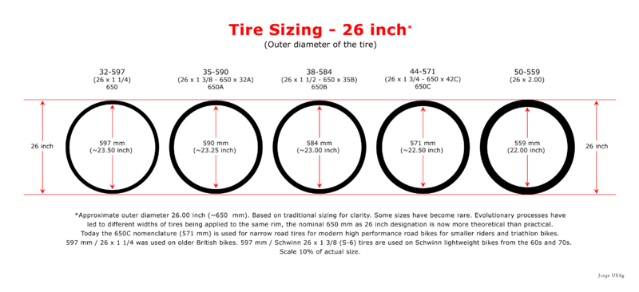

28 inch
Traditionally, there were four different sizes of 28-inch diameter wheels, from the narrow tires to the widest, they all measured the same outside diameter, which coincide with four different families of 700 tire sizes, these are 700, 700A, 700B and 700C. The largest of these rims (ISO 647mm/642mm) with the narrower tires are no longer available.
28 Inches
Obsolete sizes in grey
Size | Code | ISO | Application
28 x 1¼ | 700 | 647mm | Old English and Dutch Bicycles / Old track bicycles
28 x 1⅜ | 700A | 642mm | Most old English sports bikes, almost extinct, now available in the Asia Pacific and the Middle East regions
28 x 1½ | 700B | 635mm | Roadster type bicycles of English, Dutch, Chinese and Indian origin / Classic Path Racer type bicycle of English origin / Maintaining in popularity throughout the world
28 x ¾  28 x 1⅛  28 x 1¼  28 x 1⅝  28 x 1¾  29 x 2⅜ | 700C | 622mm | ISO 18-622 through ISO 28-622, for racing bicycles, narrow wheels and the diameter of the wheel is less than 28 inches  ISO 32-622 through ISO 42-622, traditional urban bicycle size  ISO 47-622 (28 × 1.75) through ISO 60-622 (29 × 2.35). The 28 x 2.00, ISO 50-622 onwards, as a marketing term for wide tires for mountain bikes, are known as 29 inch for their larger wheel diameter

Rolling resistance
There are a number of variables that determine rolling resistance: tire tread, width, diameter, tire construction, tube type (if applicable), and pressure are all important.
Smaller diameter wheels, all else being equal, have higher rolling resistance than larger wheels."Rolling resistance increases in near proportion as wheel diameter is decreased for a given constant inflation pressure."

Reaction to load (tensioned wire spoked wheels)
The reaction to a radial load of a well-tensioned wire spoked wheel, such as by a rider sitting on a bicycle, is that the wheel flattens slightly near the ground contact area. The rest of the wheel remains approximately circular. The tension of all the spokes do not increase significantly. Instead, only the spokes directly under the hub decrease their tension. The issue of how best to describe this situation is debated. Some authors conclude from this that the hub "stands" on those spokes immediately below it that experience a reduction in tension. Other authors conclude that the hub "hangs" from those spokes above it that have higher tension than the ones below it.
Despite being composed of thin and relatively flexible spokes, wire wheels are radially stiff and provide very little suspension compliance compared to even high-pressure bicycle tires.

Rotating mass
Due to the fact that wheels rotate as well as translate (move in a straight line) when a bicycle moves, more force is required to accelerate a unit of mass on the wheel than on the frame. To accelerate a wheel, total wheel mass matters less than the moment of inertia, which describes the inertial effect of the mass resisting acceleration (inertia) based on its location with respect to the axis of rotation (the center of the wheel hub/axle). In wheel design, reducing the rotational inertia has the benefit of more responsive, faster-accelerating wheels. To accomplish this, wheel designs are employing lighter rim materials, moving the spoke nipples to the hub or using lighter nipples such as aluminum. Note however that rotational inertia is only a factor during acceleration (and deceleration/braking). At constant speed, aerodynamics are a significant factor. For climbing, total mass remains important. See Bicycle performance for more detail.

Dish

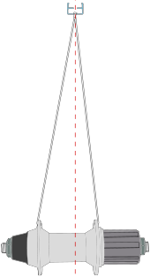
Diagram showing the difference in length and angle of spokes.
The hub flanges of modern tension-spoked bicycle wheels are always spaced wider than where the spokes attach to the rim. When viewed in cross section, the spokes and hub form a triangle, a structure that is stiff both vertically and laterally. In three dimensions, if the spokes were covered, they would form two cones or "dishes". The greater the separation between the hub flanges, the deeper the dishes, and the stiffer and stronger the wheel can be laterally. The more vertical the spokes, the shallower the dish, and the less stiff the wheel will be laterally..The dishes on each side of a wheel are not always equal. The cogset (freewheel or cassette) of a rear wheel and disc brake rotors, if installed, takes up width on the hub, and so the flanges may not be located symmetrically about the center plane of the hub or the bike. Since the rim must be centered, but the hub flanges are not, there is a difference in dish between the two sides. Such an asymmetrical wheel is called a "dished" wheel. The side of the wheel with less dish has slightly shorter but significantly higher-tensioned spokes than side with more dish. Several different techniques have been tried to minimize this spoke asymmetry. In addition to modified hub geometry, some rims have off-center spoke holes, and the mounting of common J-bend spokes at the hub flange can be altered "inboard" or "outboard".^{[59]}
A truing stand or a dishing gauge, can be used to measure the position of the rim relative to the hub. Thus "dishing" is also used to describe the process of centering the rim on the hub, even in the case of symmetrical wheels.^{[60]}
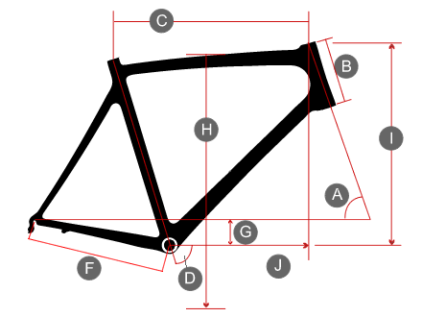

 |  |  |  |  |  |  |  |  | S(44) | M(48) |  |  | L(52) |  |  | XL(56)
A |  |  |  |  |  | Head Angle (°) |  |  | 72 |  | 72.5 |  |  | 73 |  |  | 73.5
B |  |  |  |  |  | Head Tube Length (mm) |  |  | 125 |  | 145 |  |  | 165 |  |  | 190
C |  |  |  |  |  | Effective Top Tube Horizontal (mm) |  |  | 530 |  | 547 |  |  | 570 |  |  | 590
D |  |  |  |  |  | Seat Angle (°) |  |  | 74 |  | 73.5 |  |  | 73 |  |  | 72.5
E |  |  |  |  |  | Seat Tube Length Centre to top(mm) |  |  | 440 |  | 480 |  |  | 520 |  |  | 560
F |  |  |  |  |  | Chainstay Length (mm) |  |  | 408 |  | 408 |  |  | 408 |  |  | 408
H |  |  |  |  |  | Standover Height (mm) |  |  | 720 |  | 740 |  |  | 775 |  |  | 780
I |  |  |  |  |  | Stack (mm) |  |  | 523 |  | 544 |  |  | 565 |  |  | 590
J |  |  |  |  |  | Reach (mm) |  |  | 379 |  | 385 |  |  | 397 |  |  | 405

Bicycle gearing

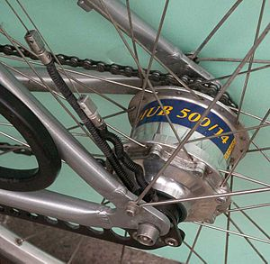
A bicycle with a hub gear.
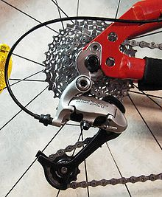

Shimano XT rear derailleur on a mountain bike

Bicycle gearing is the aspect of a bicycle drivetrain that determines the relation between the cadence, the rate at which the rider pedals, and the rate at which the drive wheel turns.On some bicycles, there is only one gear and the gear ratio is fixed. Many contemporary bicycles have multiple gears and thus multiple gear ratios. A shifting mechanism allows selection of the appropriate gear ratio for efficiency or comfort under the prevailing circumstances: for example, it may be comfortable to use a high gear when cycling downhill, a medium gear when cycling on a flat road, and a low gear when cycling uphill. Different gear ratios and gear ranges are appropriate for different people and styles of cycling.A cyclist's legs produce power optimally within a narrow pedalling speed range, or cadence. Gearing can be optimized to use this narrow range as efficiently as possible. As in other types of transmissions, the gear ratio is closely related to the mechanical advantage of the drivetrain of the bicycle. On single-speed bicycles and multi-speed bicycles using derailleur gears, the gear ratio depends on the ratio of the number of teeth on the chainring to the number of teeth on the rear sprocket (cog). For bicycles equipped with hub gears, the gear ratio also depends on the internal planetary gears within the hub. For a shaft-driven bicycle the gear ratio depends on the bevel gears used at each end of the shaft.

For a bicycle to travel at the same speed, using a lower gear (larger mechanical advantage) requires the rider to pedal at a faster cadence, but with less force. Conversely, a higher gear (smaller mechanical advantage) provides a higher speed for a given cadence, but requires the rider to exert greater force. Different cyclists may have different preferences for cadence and pedaling force. Prolonged exertion of too much force in too high a gear at too low a cadence can increase the chance of knee damage;[1] cadence above 100 rpm becomes less effective after short bursts, as during a sprint.[1]

Measuring gear ratios

Methods

There are at least four different methods for measuring gear ratios: gear inches, metres of development (roll-out), gain ratio, and quoting the number of teeth on the front and rear sprockets respectively. The first three methods result in each possible gear ratio being represented by a single number which allows the gearing of any bicycles to be compared; the numbers produced by different methods are not comparable, but for each method the larger the number the higher the gear. The fourth method uses two numbers and is only useful in comparing bicycles with the same drive wheel diameter (in the case of road bikes, this is almost universally 622 mm, as defined by the 700c standard).

Front/rear measurement only considers the sizes of a chainring and a rear sprocket. Gear inches and metres of development also take the size of the rear wheel into account. Gain ratio goes further and also takes the length of a pedal crankarm into account.

Gear inches and metres of development are closely related: to convert from gear inches to metres of development, multiply by 0.08 (more exactly: 0.0798, or precisely: ).

The methods of calculation which follow assume that any hub gear is in direct drive. Multiplication by a further factor is needed to allow for any other selected hub gear ratio (many online gear calculators have these factors built in for various popular hub gears).

• Gear inches = Diameter of drive wheel in inches × (number of teeth in front chainring / number of teeth in rear sprocket). Normally rounded to nearest whole number.

• Metres of development = Circumference of drive wheel in metres × (number of teeth in front chainring / number of teeth in rear sprocket).

• Gain ratio = (Radius of drive wheel / length of pedal crank) × (number of teeth in front chainring / number of teeth in rear sprocket). Measure radius and length in same units.

Both metres of development and gain ratios are normally rounded to one decimal place.

Gear inches corresponds to the diameter (in inches) of the main wheel of an old-fashioned penny-farthing bicycle with equivalent gearing. Metres of development corresponds to the distance (in metres) traveled by the bicycle for one rotation of the pedals. Gain ratio is the ratio between the distance travelled by the bicycle and the distance travelled by a pedal, and is a pure number, independent of any units of measurement.

• Front/rear gear measurement uses two numbers (e.g. 53/19) where the first is the number of teeth in the front chainring and the second is the number of teeth in the rear sprocket. Without doing some arithmetic, it is not immediately obvious that 53/19 and 39/14 represent effectively the same gear ratio.

Examples
The following table provides some comparison of the various methods of measuring gears (the particular numbers are for bicycles with 170 mm cranks, 700C wheels, and 25mm tyres). Speeds for several cadences in revolutions per minute are also given. On each row the relative values for gear inches, metres of development, gain ratio, and speed are more or less correct, while the front/rear values are the nearest approximation which can be made using typical chainring and cogset sizes. Note that bicycles intended for racing may have a lowest gear of around 45 gear inches (or 35 if fitted with a compact crankset).
Gear | Gear  inches | Metre  development | Gain  ratio | Front/  rear | 60 rpm |  |  | 80 rpm |  | 100 rpm |  |  | 120 rpm
 |  |  |  |  | mph |  | km/h | mph | km/h | mph | km/h |  | mph | km/h
Very high | 125 | 10 | 9.4 | 53/11 | 22.3 |  | 36 | 29.7 | 47.8 | 37.1 | 59.7 |  | 44.5 | 72
High | 100 | 8 | 7.5 | 53/14 | 18 |  | 29 | 24 | 38.6 | 30 | 48.3 |  | 36 | 57.9
Medium | 70 | 5.6 | 5.2 | 53/19 or 39/14 | 12.5 |  | 20 | 16.6 | 26.7 | 21 | 33.6 |  | 25 | 40
Low | 40 | 3.2 | 3.0 | 34/23 | 7.2 |  | 11.6 | 9.6 | 15.4 | 11.9 | 19.2 |  | 14.3 | 23
Very low | 20 | 1.6 | 1.5 | 32/42 | 3.5 |  | 5.6 | 4.7 | 7.6 | 5.9 | 9.5 |  | 7.1 | 11.4

Single speed bicycles

A single-speed bicycle is a type of bicycle with a single gear ratio. These bicycles are without derailleur gears, hub gearing or other methods for varying the gear ratio of the bicycle. Adult single-speed bicycles typically have a gear ratio of between 55 and 75 gear inches, depending on the rider and the anticipated usage.

There are many types of modern single speed bicycles; BMX bicycles, some bicycles designed for (younger) children, cruiser type bicycles, classic commuter bicycles, unicycles, bicycles designed for track racing, fixed-gear road bicycles, and fixed-gear mountain bicycles.

The fixed-gear single-speed bicycle is the most basic type of bicycle. A fixed-gear bike does not have a freewheel mechanism to allow coasting.

General considerations

The gearing supplied by the manufacturer on a new bicycle is selected to be useful to the majority of people. Some cyclists choose to fine-tune the gearing to better suit their strength, level of fitness, and expected usage. When buying from specialist cycle shops, it may be less expensive to get the gears altered before delivery rather than at some later date. Modern crankset chainrings can be swapped out, as can cogsets.

While long steep hills and/or heavy loads may indicate a need for lower gearing, this can result in a very low speed. Balancing a bicycle becomes more difficult at lower speeds. For example, a bottom gear around 16 gear inches gives an effective speed of perhaps 3 miles/hour (5 km/hour) or less, at which point it might be quicker to walk.

Relative gearing

As far as a cyclist's legs are concerned, when changing gears, the relative difference between two gears is more important than the absolute difference between gears. This relative change, from a lower gear to a higher gear, is normally expressed as a percentage, and is independent of what system is used to measure the gears. Cycling tends to feel more comfortable if nearly all gear changes have more or less the same percentage difference. For example, a change from a 13-tooth sprocket to a 15-tooth sprocket (15.4%) feels very similar to a change from a 20-tooth sprocket to a 23-tooth sprocket (15%), even though the latter has a larger absolute difference.

To achieve such consistent relative differences the absolute gear ratios should be in logarithmic progression; most off-the-shelf cogsets do this with small absolute differences between the smaller sprockets and increasingly larger absolute differences as the sprockets get larger. Because sprockets must have a (relatively small) whole number of teeth it is impossible to achieve a perfect progression; for example the seven derailleur sprockets 14-16-18-21-24-28-32 have an average step size of around 15% but with actual steps varying between 12.5% and 16.7%. The epicyclic gears used within hub gears have more scope for varying the number of teeth than do derailleur sprockets, so it may be possible to get much closer to the ideal of consistent relative differences, e.g. the Rohloff Speedhub offers 14 speeds with an average relative difference of 13.6% and individual variations of around 0.1%.

Racing cyclists often have gears with a small relative difference of around 7% to 10%; this allows fine adjustment of gear ratios to suit the conditions and maintain a consistent pedalling speed. Mountain bikes and hybrid bikes often have gears with a moderate relative difference of around 15%; this allows for a much larger gear range while having an acceptable step between gears. 3-speed hub gears may have a relative difference of some 33% to 37%;[5] such big steps require a very substantial change in pedalling speed and often feel excessive.[6] A step of 7% corresponds to a 1-tooth change from a 14-tooth sprocket to a 15-tooth sprocket, while a step of 15% corresponds to a 2-tooth change from a 13-tooth sprocket to a 15-tooth sprocket.

By contrast, car engines deliver power over a much larger range of speeds than cyclists' legs do, so relative differences of 30% or more are common for car gearboxes.

Usable gears

On a bicycle with only one gear change mechanism (e.g. rear hub only or rear derailleur only), the number of possible gear ratios is the same as the number of usable gear ratios, which is also the same as the number of distinct gear ratios.

On a bicycle with more than one gear change mechanism (e.g. front and rear derailleur), these three numbers can be quite different, depending on the relative gearing steps of the various mechanisms. The number of gears for such a derailleur equipped bike is often stated simplistically, particularly in advertising, and this may be misleading.

Consider a derailleur-equipped bicycle with 3 chainrings and an 8-sprocket cogset:

the number of possible gear ratios is 24 (=3×8, this is the number usually quoted in advertisements);

the number of usable gear ratios is 22;

the number of distinct gear ratios is typically 16 to 18.

The combination of 3 chainrings and an 8-sprocket cogset does not result in 24 usable gear ratios. Instead it provides 3 overlapping ranges of 7, 8, and 7 gear ratios. The outer ranges only have 7 ratios rather than 8 because the extreme combinations (largest chainring to largest rear sprocket, smallest chainring to smallest rear sprocket) result in a very diagonal chain alignment which is inefficient and causes excessive chain wear.[7] Due to the overlap, there will usually be some duplicates or near-duplicates, so that there might only be 16 or 18 distinct gear ratios. It may not be feasible to use these distinct ratios in strict low-high sequence anyway due to the complicated shifting patterns involved (e.g. simultaneous double or triple shift on the rear derailleur and a single shift on the front derailleur). In the worst case there could be only 10 distinct gear ratios, if the percentage step between chainrings is the same as the percentage step between sprockets. However, if the most popular ratio is duplicated then it may be feasible to extend the life of the gear set by using different versions of this popular ratio.

Gearing range

The gearing range indicates the difference between bottom gear and top gear, and provides some measure of the range of conditions (high speed versus steep hills) with which the gears can cope; the strength, experience, and fitness level of the cyclist are also significant. A range of 300% or 3:1 means that for the same pedalling speed a cyclist could travel 3 times as fast in top gear as in bottom gear (assuming sufficient strength, etc.). Conversely, for the same pedalling effort, a cyclist could climb a much steeper hill in bottom gear than in top gear.

The overlapping ranges with derailleur gears mean that 24 or 27 speed derailleur gears may only have the same total gear range as a (much more expensive) Rohloff 14-speed hub gear. Internal hub geared bikes typically have a more restricted gear range than comparable derailleur-equipped bikes, and have fewer ratios within that range.

The approximate gear ranges which follow are merely indicative of typical gearing setups, and will vary somewhat from bicycle to bicycle.

• 180% 3-speed hub gears

• 250% 5-speed hub gears

• 300% 7-speed hub gears

• 307% 8-speed hub gears

• 327% typical 1 chainring derailleur setup (1x10, 11-36)

• 350% NuVinci continuously variable transmission

• 409% 11-speed hub gears

• 420% extreme 1 chainring derailleur setup (1x11, SRAM XX1)

• 428% typical 2 chainring derailleur setup (2x10, 50-34 x 11-32)

• 526% typical 3 chainring derailleur setup (3x10); Rohloff Speedhub 14-speed hub gear

• 636% 18-speed bottom bracket gearbox

• 698% touring 3 chainring derailleur setup (3x10)

Gear ranges of almost 700% can be achieved on derailleur setups, though this may result in some rather large steps between gears or some awkward gear changes. However, through the careful choice of chainrings and rear cogsets, e.g. 3 chainrings 48-34-20 and a 10-speed cassette 11-32, one can achieve an extremely wide range of gears that are still well spaced. This sort of setup has proven useful on a multitude of bicycles such as cargo bikes, touring bikes and tandems. Even higher gear ranges can be achieved by using a 2-speed bottom bracket hub gear in conjunction with suitable derailleurs.

Types of gear change mechanisms

There are two main types of gear change mechanisms, known as derailleurs and hub gears. These two systems have both advantages and disadvantages relative to each other, and which type is preferable depends very much on the particular circumstances. There are a few other relatively uncommon types of gear change mechanism which are briefly mentioned near the end of this section. Derailleur mechanisms can only be used with chain drive transmissions, so bicycles with belt drive or shaft drive transmissions must either be single speed or use hub gears.

External (derailleur)
Main article: Derailleur gears
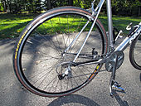
Bicycle rear wheel showing front and rear derailleurs, and rear cogset
External gearing is so called because all the sprockets involved are readily visible. There may be up to 3 chainrings attached to the crankset and pedals, and typically between 5 and 11 sprockets making up the cogset attached to the rear wheel. Modern front and rear derailleurs typically consist of a moveable chain-guide that is operated remotely by a Bowden cable attached to a shifter mounted on the down tube, handlebar stem, or handlebar. A shifter may be a single lever, or a pair of levers, or a twist grip; some shifters may be incorporated with brake levers into a single unit. When a rider operates the shifter while pedalling, the change in cable tension moves the chain-guide from side to side, "derailing" the chain onto different sprockets. The rear derailleur also has spring-mounted jockey wheels which take up any slack in the chain.
Most hybrid, touring, mountain, and racing bicycles are equipped with both front and rear derailleurs. There are a few gear ratios which have a straight chain path, but most of the gear ratios will have the chain running at an angle. The use of two derailleurs generally results in some duplicate or near duplicate gear ratios, so that the number of distinct gear ratios is typically around two-thirds of the number of advertised gear ratios. The more common configurations have specific names ^{[9]} which are usually related to the relative step sizes between the front chainrings and the rear cogset.

Crossover gearing
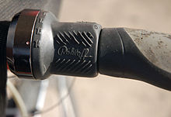
Twist grip
This style is commonly found on mountain, hybrid, and touring bicycles with three chainrings. The relative step on the chainrings (say 25% to 35%) is typically around twice the relative step on the cogset (say 15%), e.g. chainrings 28-38-48 and cogset 12-14-16-18-21-24-28.
Advantages of this arrangement include:
- A wide range of gears may be available suitable for touring and for off-road riding.
- There is seldom any need to change both front and rear derailleurs simultaneously so it is generally more suitable for casual or inexperienced cyclists.
One disadvantage is that the overlapping gear ranges result in a lot of duplication or near-duplication of gear ratios.

Multi-range gearing
This style is commonly found on racing bicycles with two chainrings. The relative step on the chainrings (say 35%) is typically around three or four times the relative step on the cogset (say 8% or 10%), e.g. chainrings 39-53 and close-range cogsets 12-13-14-15-16-17-19-21 or 12-13-15-17-19-21-23-25. This arrangement provides much more scope for adjusting the gear ratio to maintain a constant pedalling speed, but any change of chainring must be accompanied by a simultaneous change of 3 or 4 sprockets on the cogset if the goal is to switch to the next higher or lower gear ratio.

Alpine gearing
This term has no generally accepted meaning. Originally it referred to a gearing arrangement which had one especially low gear (for climbing Alpine passes); this low gear often had a larger than average jump to the next lowest gear. In the 1960s the term was used by salespeople to refer to then current 10-speed bicycles (2 chainrings, 5-sprocket cogset), without any regard to its original meaning. The nearest current equivalent to the original meaning can be found in the Shimano Megarange cogsets, where most of the sprockets have roughly a 15% relative difference, except for the largest sprocket which has roughly a 30% difference; this provides a much lower gear than normal at the cost of a large gearing jump.

Half-step gearing
There are two chainrings whose relative difference (say 10%) is about half the relative step on the cogset (say 20%). This was used in the mid-20th century when front derailleurs could only handle a small step between chainrings and when rear cogsets only had a small number of sprockets, e.g. chainrings 44-48 and cogset 14-17-20-24-28. The effect is to provide two interlaced gear ranges without any duplication. However to step sequentially through the gear ratios requires a simultaneous front and rear shift on every other gear change. This style is not available off the shelf.
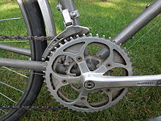
Half-step plus granny crankset with 28, 45, and 50 tooth chainrings on a Trek 620 touring bicycle

Half-step plus granny gearing
There are three chainrings with half-step differences between the larger two and multi-range differences between the smaller two, e.g. chainrings 24-42-46 and cogset 12-14-16-18-21-24-28-32-36.^{[10]} This general arrangement is suitable for touring with most gear changes being made using the rear derailleur and occasional fine tuning using the two large chainrings.The small chainring (granny gear) is a bailout for handling steeper hills, but it requires some anticipation in order to use it effectively.

Internal (hub)
Main article: Hub gear
Internal gearing is so called because all the gears involved are hidden within a wheel hub. Hub gears work using internal planetary, or epicyclic, gearing which alters the speed of the hub casing and wheel relative to the speed of the drive sprocket. They have just a single chainring and a single rear sprocket, almost always with a straight chain path between the two. Hub gears are available with between 2 and 14 speeds; weight and price tend to increase with the number of gears. All the advertised speeds are available as distinct gear ratios controlled by a single shifter (except for some early 5-speed models which used two shifters). Hub gearing is often used for bicycles intended for city-riding and commuting.

Internal (bottom bracket)
Current systems have gears incorporated in the crankset or bottom bracket. Patents for such systems appeared as early as 1890.^{[11]} The Schlumpf Mountain Drive and Speed Drive have been available since 2001 Some systems offer direct drive plus one of three variants (reduction 1:2.5, increase 1.65:1, and increase 2.5:1). Changing gears is accomplished by using your foot to tap a button protruding on each side of the bottom bracket spindle. The effect is that of having a bicycle with twin chainrings with a massive difference in sizes. Pinion GmbH introduced in 2010 an 18 speed gearbox model, offering an evenly spaced 636% range. This gearbox is actuated by traditional twist shifter and uses two cables for gear change. Pinion system is well suited for mountain bicycles due to its wide range and low gravity center suitable for full suspension bikes, but it is still somewhat heavier than derailleur based drivetrain. ^{[13]}
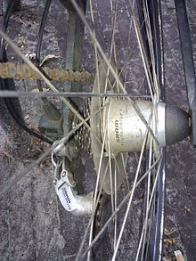
SRAM Dual Drive combination derailleur gears and hub gear

Internal and external combined
It is sometimes possible to combine a hub gear with deraileur gears. There are several commercially available possibilities:
- One standard option for the Brompton folding bicycle is to use a 3-speed hub gear (roughly a 30% difference between gear ratios) in combination with a 2-speed deraileur gear (roughly a 15% difference) to give 6 distinct gear ratios; this is an example of half-step gearing. Some Brompton suppliers offer a 2-speed chainring 'Mountain Drive' as well, which results in 12 distinct gear ratios with a range exceeding 5:1; in this case, the change from 6th to 7th gear involves changing all three sets of gears simultaneously.
- The SRAM DualDrive system uses a standard 8 or 9-speed cogset mounted on a three-speed internally geared hub, offering a similar gear range to a bicycle with a cogset and triple chainrings.
- Less common is the use of a double or triple chainring in conjunction with an internally geared hub, extending the gear range without having to fit multiple sprockets to the hub. However, this does require a chain tensioner of some sort, negating some of the advantages of hub gears.
- At an extreme opposite from a single speed bicycle, hub gears can be combined with both front and rear derailleurs, giving a very wide-ranging drivetrain at the expense of weight and complexity of operation- there are a total of three sets of gears. This approach may be suitable for recumbent trikes, where very low gears can be used without balance issues, and the aerodynamic position allows higher gears than normal.

Others
There have been, and still are, some quite different methods of selecting a different gear ratio:
- Retro-direct drivetrains used on some early 20th century bicycles have been resurrected by bicycle hobbyists. These have two possible gear ratios but no gear lever; the operator simply pedals forward for one gear and backward for the other. The chain path is quite complicated, since it effectively has to do a figure of eight as well as follow the normal chain path.
- Flip-flop hubs have a double-sided rear wheel with a (different sized) sprocket on each side. To change gear: stop, remove the rear wheel, flip it over, replace the wheel, adjust chain tension, resume cycling. Current double sided wheels typically have a fixed sprocket on one side and a freewheel sprocket on the other.
Prior to 1937 this was the only permitted form of gear changing on the Tour de France. Competitors could have 2 sprockets on each side of the rear wheel, but still had to stop to manually move the chain from one sprocket to the other and adjust the position of the rear wheel so as to maintain the correct chain tension.
- Continuously variable transmissions are a relatively new development in bicycles (though not a new idea). Mechanisms like the NuVinci gearing system use balls connected to two disks by static friction - changing the point of contact changes the gear ratio.
- Automatic transmissions have been demonstrated and marketed for both derailleur and hub gear mechanisms, often accompanied by a warning to disengage auto-shifting if standing on the pedals. These have met with limited market success.

Efficiency
The numbers in this section apply to the efficiency of the drive-train, including means of transmission and any gearing system. In this context efficiency is concerned with how much power is delivered to the wheel compared with how much power is put into the pedals. For a well-maintained transmission system, efficiency is generally between 86% and 99%, as detailed below.
Factors besides gearing which affect performance include rolling resistance and air resistance:
- Rolling resistance can vary by a factor of 10 or more depending on type and dimensions of tire and the tire pressure.
- Air resistance increases greatly as speed increases and is the most significant factor at speeds above 10 to 12 miles (15 to 20 km) per hour (the drag force increases in proportion to the square of the speed, thus the power required to overcome it increases in proportion to the cube of the speed).
Human factors can also be significant. Rohloff demonstrates that overall efficiency can be improved in some cases by using a slightly less efficient gear ratio when this leads to greater human efficiency (in converting food to pedal power) because a more effective pedalling speed is being used.

Overview
An encyclopedic overview can be found in Chapter 9 of "Bicycling Science"^{[18]} which covers both theory and experimental results. Some details extracted from these and other experiments are provided in the next subsection, with references to the original reports.
Factors which have been shown to affect the drive-train efficiency include the type of transmission system (chain, shaft, belt), the type of gearing system (fixed, derailleur, hub, infinitely variable), the size of the sprockets used, the magnitude of the input power, the pedalling speed, and how rusty the chain is. For a particular gearing system, different gear ratios generally have different efficiencies.
Some experiments have used an electric motor to drive the shaft to which the pedals are attached, while others have used averages of a number of actual cyclists. It is not clear how the steady power delivered by a motor compares with the cyclic power provided by pedals. Rohloff argues that the constant motor power should match the peak pedal power rather than the average (which is half the peak).
There is little independent information available relating to the efficiency of belt drives and infinitely variable gear systems; even the manufacturers/suppliers appear reluctant to provide any numbers.

Details
Derailleur type mechanisms of a typical mid-range product (of the sort used by serious amateurs) achieve between 88% and 99% mechanical efficiency at 100W. In derailleur mechanisms the highest efficiency is achieved by the larger sprockets. Efficiency generally decreases with smaller sprocket and chainring sizes.^{[19]} Derailleur efficiency is also compromised with cross-chaining, or running large-ring to large-sprocket or small-ring to small-sprocket. This cross-chaining also results in increased wear because of the lateral deflection of the chain.
Chester Kyle and Frank Berto reported in "Human Power" 52 (Summer 2001)^{[20]} that testing on three derailleur systems (from 4 to 27 gears) and eight gear hub transmissions (from 3 to 14 gears), performed with 80W, 150W, 200W inputs, gave results as follows:
Transmission Type | Efficiency (%)
Derailleurs | 87-97
Gear Hubs | 86-95
Efficiency testing of bicycle gearing systems is complicated by a number of factors - in particular, all systems tend to be better at higher power rates. 200 Watts will drive a typical bicycle at 20 mph, while top cyclists can achieve 400W, at which point one hub-gear manufacturer (Rohloff) claims 98% efficiency

CHAPTER 6

CONCLUSION

- Since efficiency of the vehicle increases, as we know that there is increasing threat on the scarcity of petroleum. This type of vehicle would help a lot in energy saving.
- Both wheel drive bicycle let the user to invest less and utilise more.
- Since the rider does not need to counter steer and can avoid rear wheel slides, control of power becomes much easier
- The central gearing system enables the user to paddle the vehicle more conviniently, as the power required to drive the paddle will be less as compared to single wheel bicycle.
- Better utilisation of power extracted from the user.
- As the cost of the vehicle is less and operates without fuel. Its user may belong to any income group, which is a better alternative for single wheel drive cycles and fuel consumeable vehicles.
- As the vehicle is Eco green and require less maintainance, it is best recommendation for Environmental Protection and Health.

